# Assignment -3

Python Programming

|  |  |
| --- | --- |
| Assignment Date | 19 September 2022 |
| Student Name | Ms. Subasri.D.R |
| Student Roll Number | 820419104073 |
| Maximum Marks | 2 Marks |

# Question-1:

Consider a list (list = []). You can perform the following commands: insert i e: Insert integer at position . print: Print the list. remove e: Delete the first occurrence of integer . append e: Insert integer at the end of the list. sort: Sort the list. pop: Pop the last element from the list. reverse: Reverse the list. Initialize your list and read in the value of followed by lines of commands where each command will be of the types listed above. Iterate through each command in order and perform the corresponding operation on your list.

|  |
| --- |
| **Solution:** |
| list=[11,2,3,5,6,7,8]  print("insert") list.insert(4,10) print(list) print("append") list.append(40) print(list) print("pop") list.pop() print(list) print("print") print(list) print("remove") list.remove(5) print(list) print("sort") list.sort()  print(list) |

|  |
| --- |
| print("reverse")  list.reverse() print(list) |
|  |

# Question-2:

Write a Calculator program in Python?

|  |
| --- |
| **Solution:** |
| def add(x, y):  return x + y  def subtract(x, y): return x - y  def multiply(x, y): return x * y  def divide(x, y):  return x / y |

print("Select operation.") print("1.Add") print("2.Subtract") print("3.Multiply") print("4.Divide")

while True:

choice = input("Enter choice(1/2/3/4): ") if choice in ('1', '2', '3', '4'):

num1 = float(input("Enter first number: ")) num2 = float(input("Enter second number: "))

if choice == '1':

print(num1, "+", num2, "=", add(num1, num2))

elif choice == '2':

print(num1, "-", num2, "=", subtract(num1, num2))

elif choice == '3':

print(num1, "*", num2, "=", multiply(num1, num2))

elif choice == '4':

print(num1, "/", num2, "=", divide(num1, num2))

next_calculation = input("Let's do next calculation? (yes/no): ") if next_calculation == "no":

break

else:

print("Invalid Input")

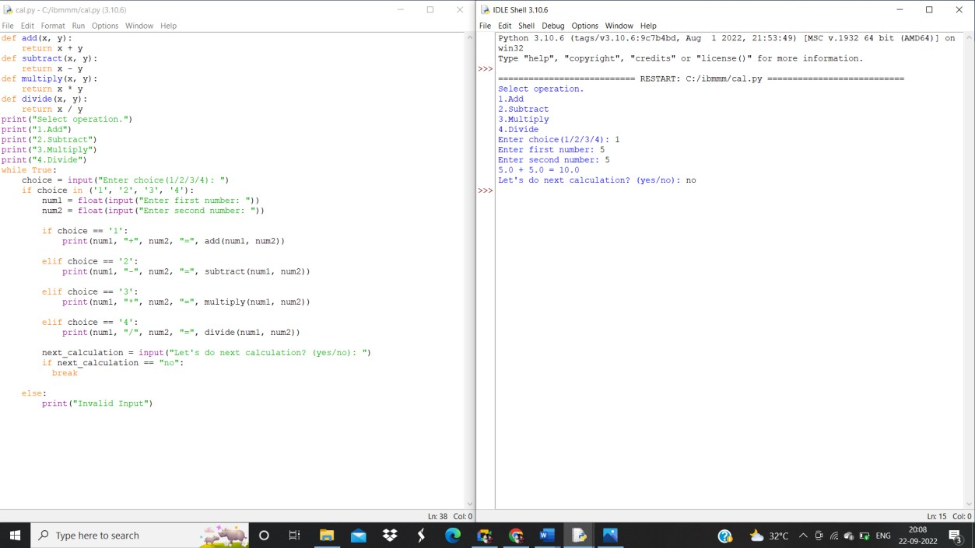

# Question-3:

Write a program to concatenate, reverse and slice a string?

**Solution:**

var1 = "Hello " var2 = "World" var3 = var1 + var2

print("concatenation") print(var3)

def rev(x):

return x[::-1]

mytxt = rev("hello world") print("reverse") print(mytxt)

def slice(y): return y[1:3]

txt = slice("hello world")

print("slice") print(txt)

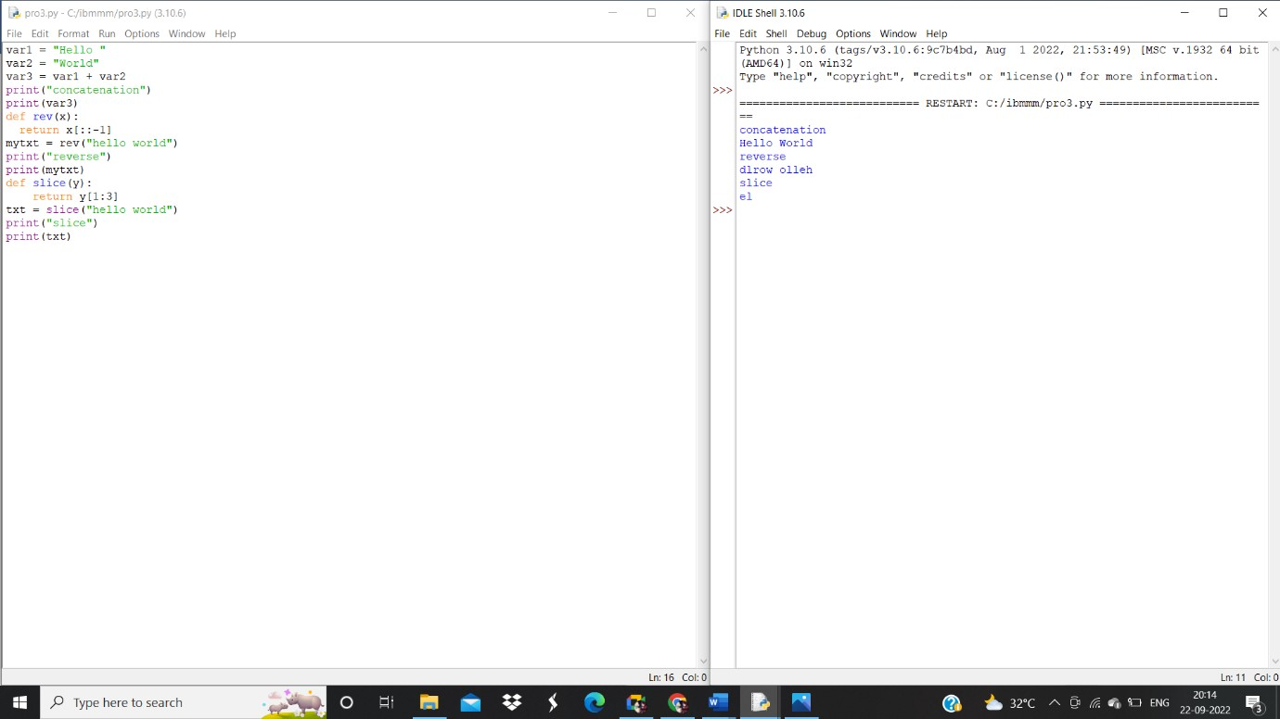

# Question-4:

Why is Python a popular programming language? Full form of WSGI

Due to its ease of learning and usage, Python codes can easily be written and executed much faster than other programming languages. One of the main reasons why Python's popularity has exponentially grown is due to its simplicity in syntax so that it could be easy to read and developed by amateur professionals as well

# Question-5:

What are the other Frameworks that can be used with python?

Examples of Python frameworks that support WSGI include Django, CherryPy, Flask, TurboGears, and web2py.

# Question-6:

Full form of WSGI

Web Server Gateway Interface